Bloody Mary’s Victims: The Iconogmphy of John Foxe’s Book of Martyrs

0. T. Hargrave

next to the English Bible, no other book enjoyed greater popularity among English Protestants in the sixteenth and seventeenth centuries than John Foxe’s “Book of Martyrs.” First published in English in
1563, the book went through four editions during Foxe’s lifetime, and nine by 1684. Foxe’s work provided the most complete, perhaps the most con- vincing, and certainly the most absorbing account of the Marian persecution to reach the English public.
From the beginning the text of the book was elaborately illustrated with graphically-drawn woodcuts. Numbering over one hundred, the anonymous- ly-crafted pictures portrayed a broad range of subjects and scenes drawn fom Foxe’s account. Although often overlooked by students of the period, the iconography of the book must have accounted in some significant mea- sure for Foxe’s success.
Mary Tudor succeeded to the English throne in July, 1553, upon the death of her younger half-brother Edward VI. Although she enjoyed an initial wave of acclaim, her popularity proved to be short-lived. Her mar- riage to Philip of Spain and her pursuit of formal reconciliation with Rome soon alienated many of her subjects.
Mary’s policy toward the English reformers was at first cautious and ten- tative. During the first year of her reign many Protestant leaders were al- lowed to flee the country, while others quietly went underground. Those who persisted in their opposition to the new policies, however, were in due course arrested, imprisoned, and tried on one charge or another. When to- ward the end of 1554 Parliament voted to revive the medieval laws against heresy, Mary launched a direct and violent attack against the reformers. During the remaining four years of her reign approximately 275 persons were executed on her orders.
Among Mary’s victims were several of the leading Protestant reformers, including Archbishop Thomas Cranmer and Bishops Hugh Latimer and Nicholas Ridley. Other well known Protestants who suffered were John
Mr. Hargrave is Associate Professor of History at Southern Methodist University. Illustrations are from the Special Collections of Bridwell Library, Southern Meth- odist University—Editor’s note.

8 HISTORICAL MAGAZINE

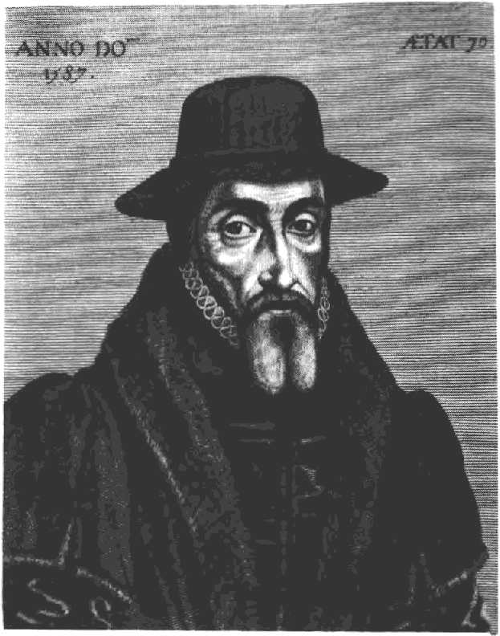
Plate 1

Rogers, the biblical translator and prebendary at St. Paul’s, Bishop John Hooper of Gloucester, Bishop Robert Ferrar of St. David’s in Wales, Dr. Rowland Taylor of Hadleigh, and the noted preacher John Bradford. Scores of others of lesser stature, among whom as many as 50 were women, were also included among the victims.
Judged by contemporary continental standards the religious persecution of Main’s reign may not have been excessive. But it was unprecedented in the English experience and by Mary’s death in 1558 had succeeded only in alienating much of the country. From his exile in Geneva John Knox ex- pressed the feelings of many Englishmen when he wrote of the “monstrous crueltie” of “that professed enemie of God, mischievous Mary.”'
It was the work of Knox’s fellow exile and historian-martpñologist extra- ordinaire John Foxe, however, which did the most to perpetuate anti-Marian sentiment [see plate 1]. Foxe’s Book of Martyrs masterfully exploited the Marian persecution, converting it, as Gordon Rupp put it, into “the greatest single act of propaganda in history.”°
Upon Mary’s accession to the throne Foxe had fled to the continent, first to Strassburg, then Frankfurt, and finally Basel. He had returned to England in November, 1559, where he had formed a lasting association with the Lon-
* '’Pte First Blow of the Trumpet Agoinst the Monstrous Regiment of Women (1558), and Knox to Sir William Cecyll (1559), The Works of John Know, ed. David Laing, 6 vols. (Edinburgh: Thomas George Stevenson, 1848-1864), 4:420;
8: 16.
*Sir Molers o/ English Religion, 1500-1700 (London: Hodder and Stoughton, 1957), p. 67.

ICONOGRAPHY OF FOXE’S BOOK OF MARTYRS 9

don printer John Day, in collaboration with whom he published his Book of
Martyrs in 1563.
The origins of the work dated back to 1552, when Foxe first began collect- ing materials on the victims of Roman Catholic persecution in England. While in exile he had published two preliminary Latin treatises on the sub- ject, taking his account down to the execution of Cranmer in 1556.° He en- titled the work which appeared in 1563, Actes and Monuments o/ These Latter and Periffoos Times. A large folio volume containing nearly 1,800 pages, the book included an English translation of his earlier work, to which was added a vast amount of new material.
Foxe attempted to set the Marian persecution within the broader context of the history of the Christian Church, the Church of England, and the Protestant Reformation. He sought to show that Mary’s victims were worthy of being placed in the company of the great martyrs of the earliest days of the Church. “If Martyrs are to be compared with Martyrs,” he wrote in his preface, “I see no cause why the Martyrs of our time deserve not as great commendation as the other in the primitive church.”*
Among his preliminaries Foxe included an address to his Catholic readers:
Se and behold, I beseche you here in this story the pityfull slaughter of your butchery. Beholde your own handy woorke, consider the nom- her almost out of nomber of so many, silly & symple lambes of Christ, whose bloud you have sought and suckt, whose lyres you have vexed, whose bodies you have slayne, racked and tormented, some also you have cast on dunghils, to be devoured of Foules and Dogges, wythout mercy, without measure, without al sense of humanity.°
And yet for all his stress upon the Marian terror, Foxe’s mood was one of triumph and victory. As Helen C. White has observed, the terror “is the terror of things remembered; it in no way impairs the confidence of the victory.”G
Foxe soon found himself compelled to plan a new edition of his book, as its wide dispersal had produced a flood of new information. Consequently, in 1570 he published a greatly enlarged revision, printed in two gigantic folio volumes. Other Elizabethan editions followed in 1576, 1583, and 1596. The response to the book among English Protestants was enthusiastic to say the least. In 1571 the convocation of Canterbury issued canons requiring

*These were his Commentorii fterum in ecclesia gestorutn (Strassburg: Wendelin Rihelius, 1554), and his Return in Ecclesia gestarutn .. . Commentarii (Basel: Nicholas Brilinger and John Oporinus).
*“A Declaration Concerning the Utilitie and Profite of thys History,” Actes end Monuments o{ these Letter and Perillous Dayes, 'touching Matters o{ the Church, Wherein ar Comprehended and Described ltte Ureot Persecutions E Horrible Trou- bles, 'Shot Have Bene Wrought and Practised by the ftomishe Prelates, Speciollye in this Realme ol England and Scotlonde, {rom the ¥eare oJ our Lorde a Thou- sande, unto the T yme None Present (London: John Day, 1563).

5 “To the Persecutors of Gods Truth, Commonlye Called Papistes,” Monuments.
Actes and

Tudor Books oJ Soints oitd Martyrs (Madison, Wisconsin: Wisconsin Press, 1963), p. 141.
The University of

10 HISTORICAL MAGAZINE

that a copy be installed in every cathedral church and in the house of each member of the hierarchy, from archbishop down to resident canon.7 The same year the mayor and corporation of London ordered it placed in city orphanages and the halls of city companies.8 By 1577 it was available for visitors at the o&ces of court as well.il Francis Drake took along a copy on his voyage around the world, whiling away dull days at sea by coloring its pictures,1° and during its early years the East Indian Company included it among the supplies to be sent out to its stations.11
Foxe’s narratives were written in a plain and straightforward style which in and of itself is anything but exciting. Yet his extensive use of the words of his martyrs, both written and spoken, and his notable skill in presenting the striking and dramatic detail, enabled him to infuse life and vitality into the scenes which he described. The stories of the examinations and disputa- tions, of the imprisonments and tortures, and above all of the final scenes at the stake were told with such power and persuasion that their impact upon his contemporaries must have been deep and unforgettable.
Nor was the audience of the Book of Martyrs confined to Foxe’s literate contemporaries.12 From the beginning the text of the book was illustrated with numerous woodcut drawings. Its fifty-four cuts in 1563, increasing to 105 in 1570, made it the most elaborately illustrated book yet to be printed in England. There can be little doubt that the woodcuts added considerably to the popularity and impact of the book.
The identity of the artist of the woodcuts is not known. He may well have

"'A Booke of Certaine Canons, Concerning Son Porte of the Discipline o{ the
Ghurche o{ England (London: John Day, 1561), pp. €›-9.
® Edward Arber, ed., A Transcript o{ the flegister o{ the Company o{ Stotiotters
o{ London, 155W16d0 A.D., 5 vols. (London, 1875—1894), 1: 496.
*William Harrison, “An Historicall Description of the Hand of Britaine,” Holin- shed’s Chronicles o{ England, Scotland, and Ireland, 6 vols. (London, 1807), 1: 881. 1°Zelia Nuttall, New Light on Droke; A Collection o{ Documents flefoting to his Voyage o{ Circumnaoigation, 1577-1580, The Hakluyt Society, ser. ii, vol. 34
(1914), pp. 19, 348, 354-57.
1 *Arnold Wright, Eorly English Adoentu hers itt tftc East (London: Andrew Mel- rose, Ltd., 1917) pp. 70=-71.
1*It is iiiipossible to deteriiiine with any degree of precision the proportion of the
population of sixteenth century England which was literate. ThOl3 .IS More’s re- markable assertion in his Apology of 1533 that “farre iiiore then four partes of all the whole dyvyded into tenne, could never rede englyshe yet,” and Bishop Stephen Gardiner’s declaration in a letter of May, 1547 that “not the hundreth part of the realme” was able to read, not only contradict each other, but were hardly intended as exact statistical statements. H. B. Bennett concludes that the “ability to read was widespread; that it was to be found in all ranks of society, aiiiong both men and woiiien, and that it was powerfully increased by the products of the printing press and by the strong religious emotions provoked by the action of Henry VIII and by later rrlonarchs and their advisers.” The Complete Works o{ Thomas More, Vol. 9, ed. J. B. Trapp (New HilVen .ind London: Yale University Press, 1979), p. 13; The Letters o{ Stcphett •ardincr, cd. Jaimes Arthur Muller (CillTlbridge: The University Press, 1933), p. 274; H. S. Bennett, fttgiish Books and Readers, 1588 to 1603; Being a Study in tlic History o{ the Book J’radc in the Reign of Eiizofieth I (Cambridge: The University Press, 1965, p. 29.

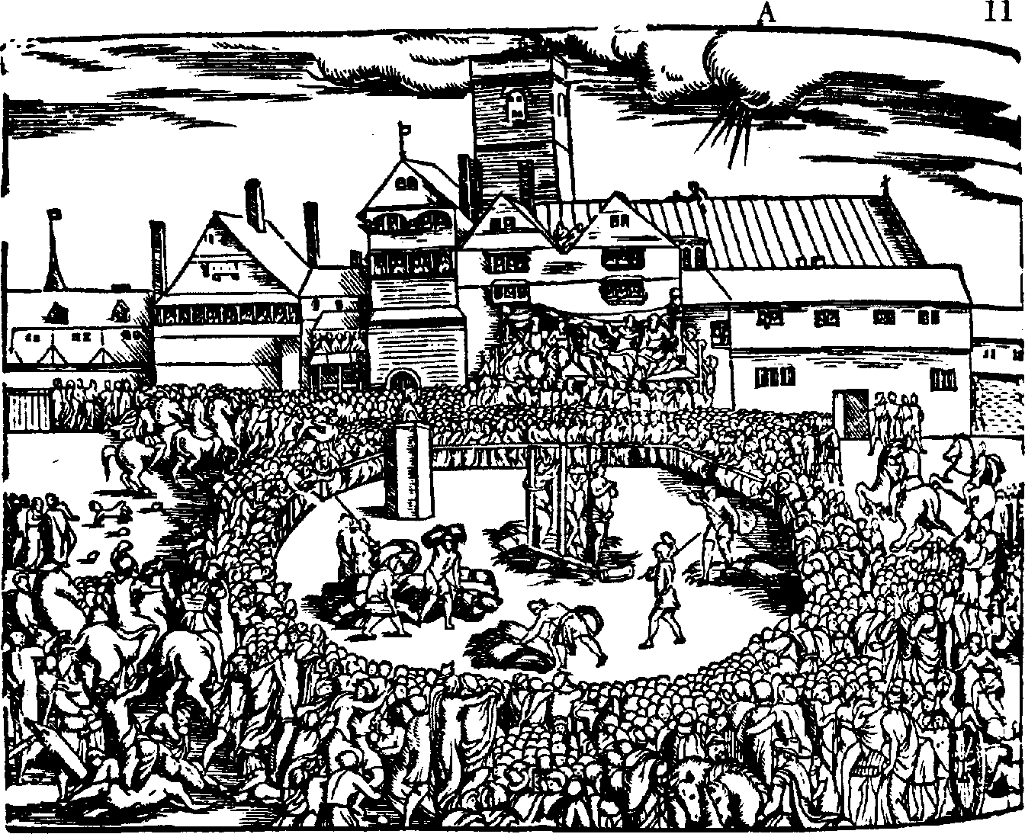Plate *
ICONOCRAPHY OF FOXE’S BOOK OF 81 RTYRS

been one of the several foreign-born artist-cutters employed by John Day.*° Whoever he was, he was a cr‹iftsm‹in of some ability whose work on the
whole was careful and r • instaking. While some of his r iC tures are crude, repetitive, and unimaginative, his best work displays a quality of character and intensity worthy of some of the more celebrated artists of the period.
His style is tyPically bold and sharply focused on the essential details. While as a portraitist most of his faces are types, he demonstrates a thorough fa- miliarity with English facial features.
The subject matter selected for illustration varied considerably and re-
flected the broad scope of Foxe’s historical treatment. Readers were shown such scenes as the Holy Roman EmPeror Henry IV waiting barefoot in the
snow outside the entrance to the r pe’s residence at Canossa; r e Alex-
ander III trending on the neck of the E r eror Frederick; the burning of
John Wycliffe’s hones; and the hanging of Richard Hunne.
The majority of the illustrations, however, dealt with the Marian persecu- tion itself. Protestant prisoners were shown being interrogated, bound in stocks, and tortured on the rack by their clerical tormentors. But it was in the depiction of the horror of the burnings that the illustrations achieved their greatest and most emotional impact. Here interest might vary from the number of people suffering together, to a unique gesture at the stake, to the

'"Alfred W. Pollard, Fine Books (New York: Cooper Squares Publishers, Inc., 1974), p. 263: Leslie Mahin Oliver “The Actes and Monuments of John Foxe: A Study of the Crowth and Influence of a Book” (Ph.D. dissertation, Harvard Uni- versity, 1945), p. 145.

12 HISTORICAL MACAZI NE

especially agonizing death of one of the victims. But whatever the particular focus, Foxe and his illustrator were at their dramatic best in these scenes (see plates 2 and 3).
Through all the illustrations the basic themes remained constant, closely paralleling those of the written text. In one way or another most of the pic- tures called attention to the cruelty of the papist tormentors, depicted with
all their unsavory attributes, and the triu r hant witness of the martyrs, whose courage and steadfastness in suffering are reflected in the serenity of their countenances.
The title page of the first edition in 1563 is 9 r ical of Foxe’s approach and sets the tone for the other illustrations (see plate 4). An elaborate pro- duction consisting of seven separate but related scenes, the page depicts
Christ’s judgement upon the persecuted and the persecuting churches—a favorite theme of Protestant polemics. Moving from bottom to top the reader is shown three pairs of contrasting scenes: a grour I Protestant men and
women listening to a preacher, Bibles r en on their laps, contrasted with a
Catholic group being instructed by a priest, rosaries in their hands, as a
procession marches toward a crucifix in the background; Protestant martyrs in flames at the stake, contrasted with Catholics at the mass, kneeling at the elevation of the host; and the risen Protestant saints in heaven, crowns upon their heads, r alms in their hands, and trumpets at their lips, contrasted with Catholic priests being cast down to hell by devils. At the top of the page
Christ the Judge r resides over all, £anked on either side by trumpeting an- gels, the world at his feet. The message may be a simple and familiar one, but it is told with unmistakable power.
In several of the illustrations Bishop Edmund Bonner is cast as the arch-
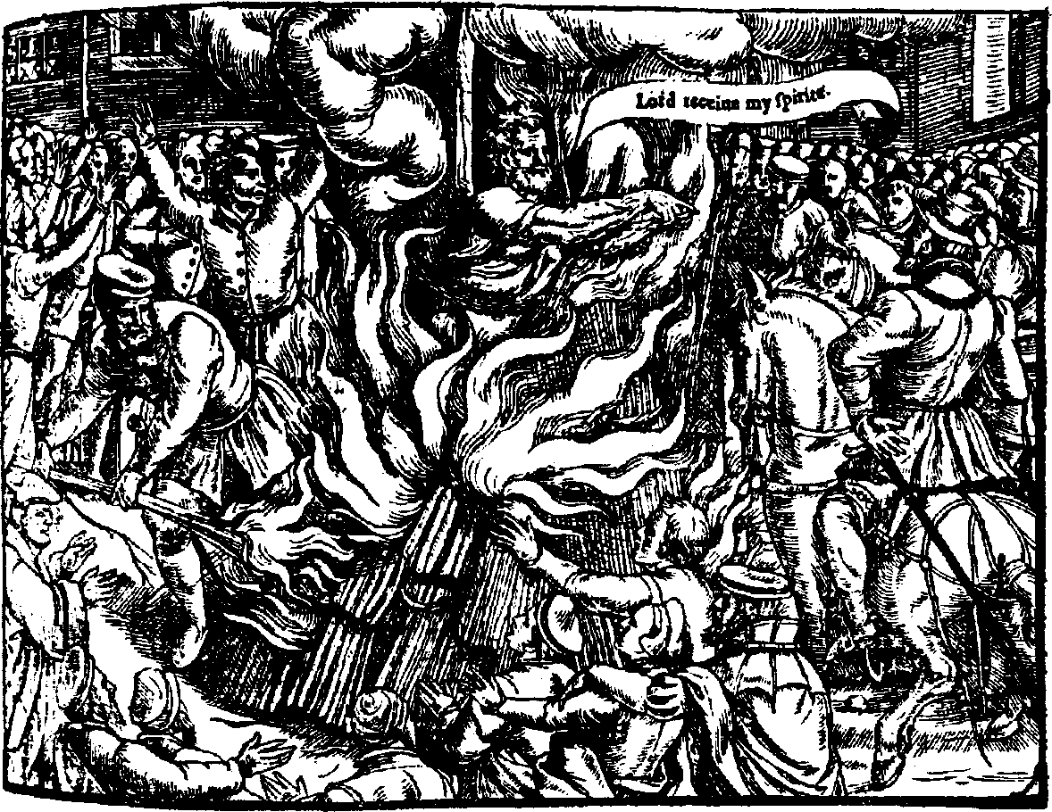
Plate 3

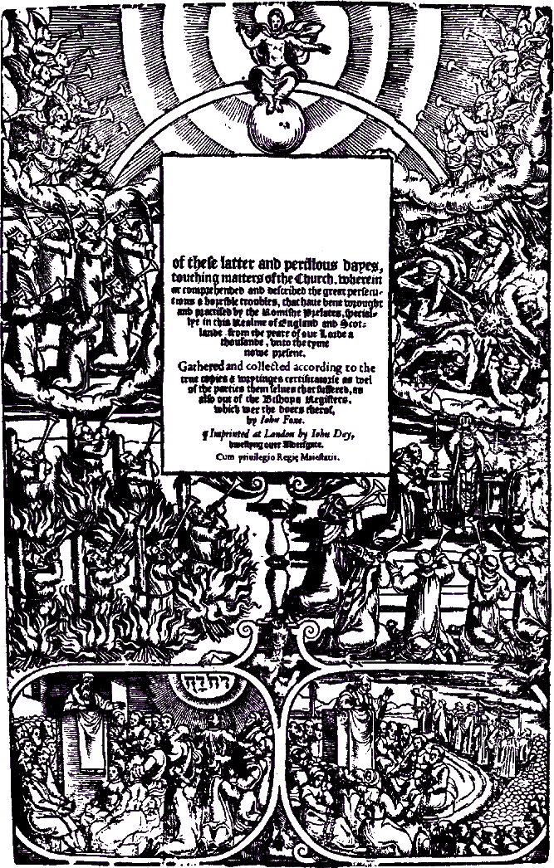
ICONOCRAPHY OF FOXE'S ROOK OF MARTYRS 13

and Vlonu ments

Plate 4

14 HISTORICAL MAGAZINE

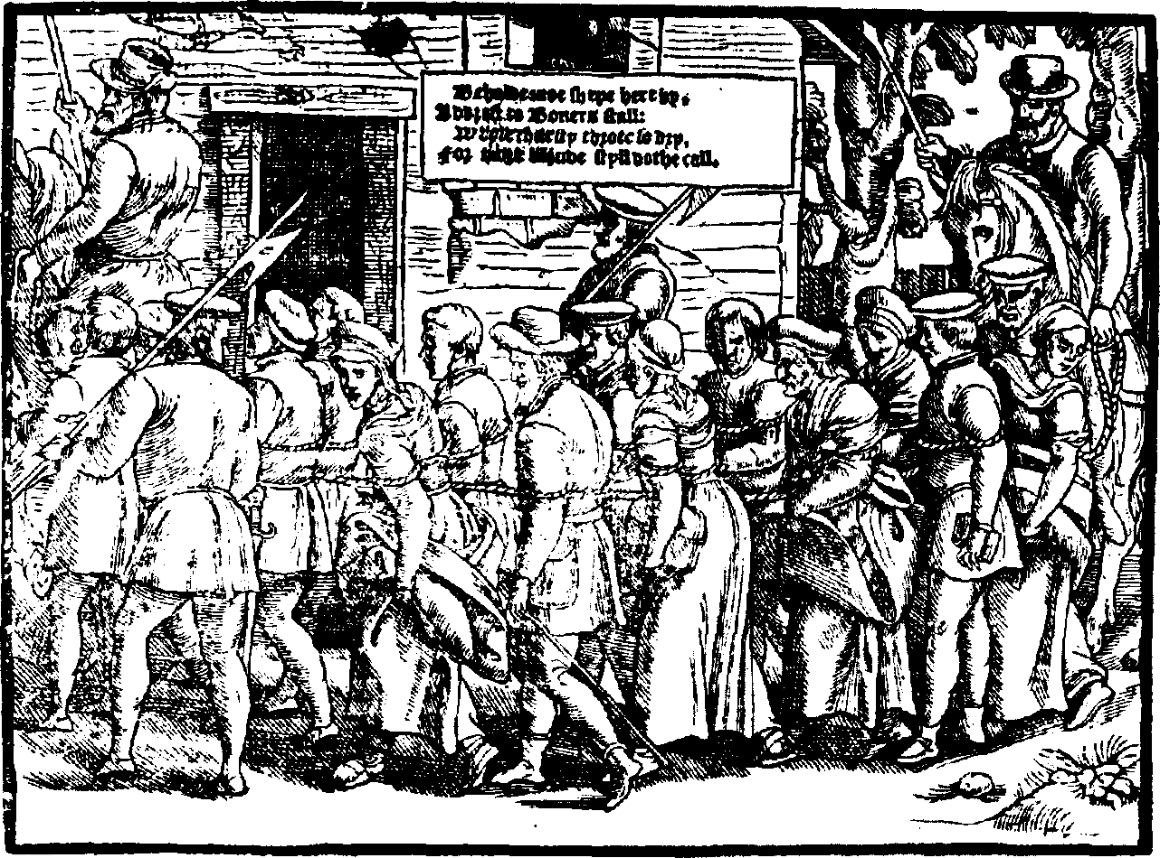
Plate 5

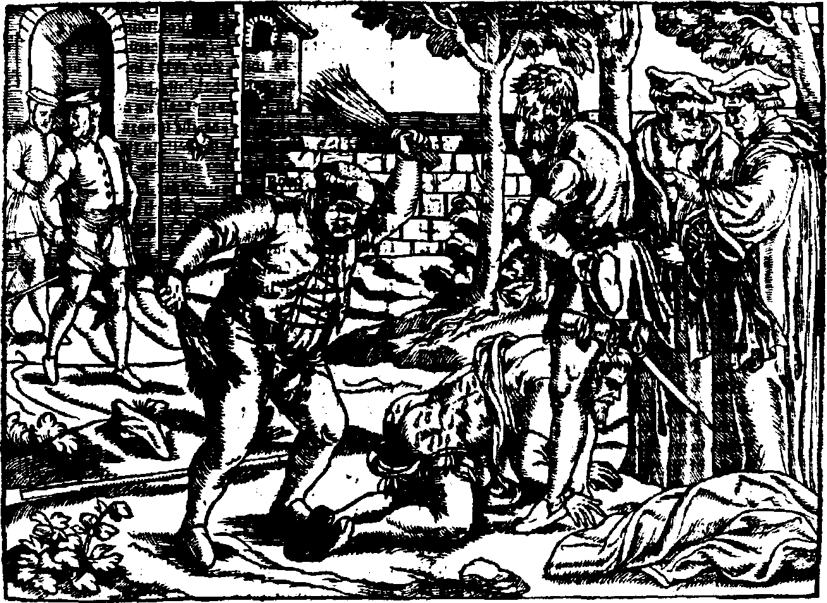
Plate 6

ICONOGRAPHY OF FOXE’S BOOK OF MARTYRS 15

villain among the persecutors. “Among all the Bishops,” Foxe wrote, “Boner bishop of London was the greatest boucher against the poore members & saints of Christ.”1* As Bishop of London, of course, he was bound to handle a disproportionately large share of the cases. His coarse personality and im- posing style also contributed to his unen viable reputation. Recent scholar- ship, however, has to some extent exonerated him of the charge of blood- thirsty persecutor.1*
In one picture a group of Protestant men and women from Colchester are shown bound together and being marched off to “Boners stall,” who “for more bloude styll dothe call” (see plate 5). A young woman among them is shown glancing back in resignation, perhaps toward family, friends, or home left behind.
In another picture Bonner himself is depicted whipping a bearded Prot- estant prisoner in his orchard, as his attendants cover their faces or turn away to avoid the sight (see plate 6). According to Sir John Harington, when Bonner was shown the print he laughed and said: “A vengeance of the foole, how could he get my picture drawne so right?” When reproached for whipping an old man with a beard, he replied, “If thou hadst bene in his case, thou wouldst have thought it a good commutacion of penance, to have thy bumme beaten, to save thy bodie from burning.” I Assuming the words to be Bonner’s, there would seem to be an unintended irony in this image, considering his reputation as heartless persecutor.
In both text and illustrations the treatment of the burning of the three Oxford martyrs, Latimer, Ridley, and Cranmer, repesented the dramatic high point of Foxe’s work. In March, 1554 the three reformers had been transferred from London to Oxford, where they had been examined and condemned. Owing to questions concerning the legality of their sentences, however, their executions had been delayed until the following year.
In September, 1555 Latimer and Ridley were again tried and condemned. On October 16 they were burned together just outside the city wall, “in the Dytch over agaynste Baily College.” The woodcut of the burning is one of Foxe’s most elaborate (see plate 7). The two men are shown chained back to back to a common stake. Armed soldiers form a circle to keep the crowd of onlookers at a safe distance. City and university officials sit to the side, while Richard Smith preaches the sermon. The text for the occasion was I Corin- thians 13: 3: “If I yelde my bodie to the fler to bee burnte, and have not Charitie, I shall gaine nothing therby.” Cranmer is shown observing the whole scene from atop the nearby Bocardo prison, where he was being de- tained at the time.17

l4Actes mid Monuments, p. 1546.
lOCf. Gina Alexander, “Bonner and the Marian Persecutions,” History, 60 (Oc-
tober, 19Y5): 3Y4—91.
1 *Nugne Antiquae: Being a Miscellaneous Collection of Original Papers, in Prose and Verse; W ritten During the Reigns oJ Henry VIII, Edward VI, Queen Mum, Elizabeth, and King James, sel. Henry Harington, ed. Thomas Park, 2 vols. (Lon- don: J. Wright for Vernon et al., 1804), 2: 34.
17 ctes and Monuments, pp. 1376—77.

16 HISTORICAL MAGAZINE
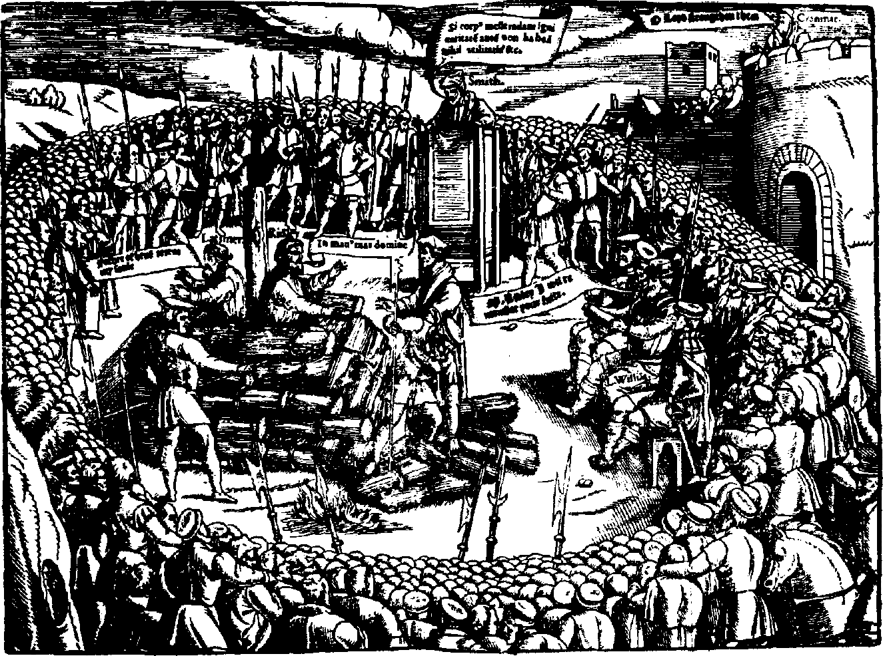

Plate 7

It was just as the fagots were lit that Latimer, breaking through the ten- sion of the moment, uttered his memorable words to his companion: “Be of good comfort M. Ridley and play the man: we shall this day lyght such a candle by Cods grace in England, as (I trust) shall never be put out.”' Aged and frail, Latimer died very soon thereafter. But the fire was badly managed on the other side, and Ridley sufiered through a long and ex- tremely painful ordeal.
The burning of Cranmer was an event of special interest and importance, both because he had been Archbishop of Canterbury, and because of his much-publicized recantations. Since he had refused to recognize the juris- diction of the court which had tried the other two, his case had been re- ferred directly to Rome. Pope Paul lV in turn had authorized an inquiry by three English clerics, on the basis of whose findings Cranmer had been con- demned, deprived of his archbishopric, and excommunicated. In February, 1556 he had been formally degraded by a special papal commission and turned over to the secular authorities for punishment.
Induced by the prospect that his life might be spared if he recanted, and influenced by his long-standing commitment to the principle of submission to the temporal power, Cranmer had been persuaded to sign six increasingly specific recantations. With these discrediting documents in hand, Mary had then given the order for his execution. He was burned at the stake on March

l8EcefesiasticnfI H’ i:tong, G ontayning the Actec G Mon.uments, 2nd ed. (London: John Day, 1570), p.1937.

ICONOGRAPHY OF FOXE’S BOOK OF MARTYRS 17
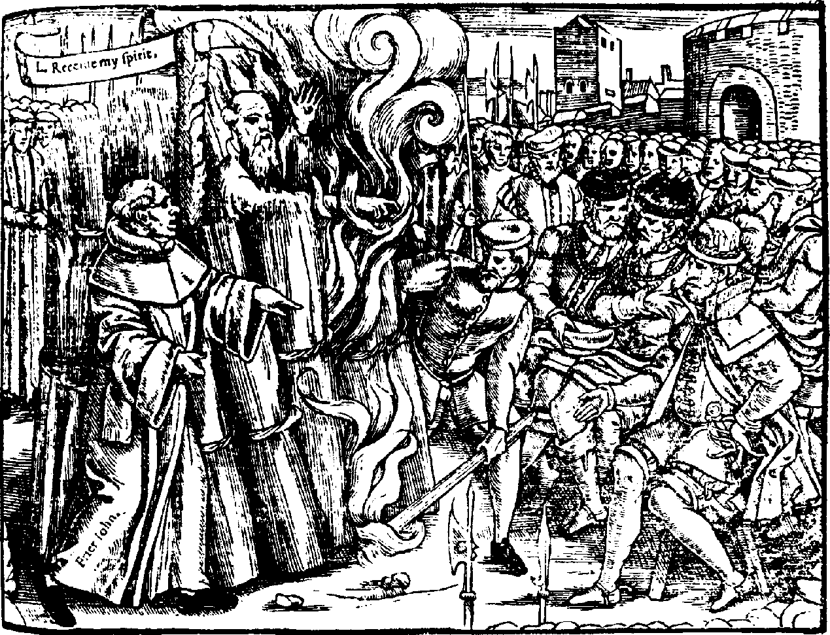
Plate 8

21, 1556, but not before publicly and dramatically repudiating his recanta- tions.
On the day of his execution Cranmer was led in procession from the Bo- cardo to St. Mary’s Church, where a large crowd had assembled for the final ceremony. Cranmer stood on a stage which had been erected facing the pulpit, while Dr. Henry Cole preached the sermon. When called upon to speak, Cranmer astounded the audience, which had been led to expect a final recantation, by dramatically renouncing his former statements:
And nowe I come to the great thyng that so muche troubled my con- science more than any thynge that ever I did or sayde in my whole lyfe, and that is the settyng abrode of a wrytinge contrarie to the truthe, whiche nowe here I renounce and refuse as thynges wrytten with my hande contrarye to the truthe, which I thought in my harte, and written for feare of deathe, and to save my lyfe if it myght be, and that is, all .such bylles and papers whiche I have wrytten or signed with my hande sence my degradation, wherein I have wrytten manye thynges untrue. And for as much as my hande offended, wrytyng con- trarie to my harte, my hande shal first be punyshed therfore. For maye
I come to the fyre, it shalbe first burned. And as for the Por e, I refuse hym as Christes enemye and Antichriste, with all his false doctrine.' ®
In the chaos which followed, Cranmer was dragged from the platform and hurried off to the stake. Foxe’s woodcut depicts the final scene (see plate 8). Encircling the stake are the familiar authorities, a persistent Span-
'°Actes and âf ontimenfs, p. lo0l.

18 HISTORICAL MACAZINE
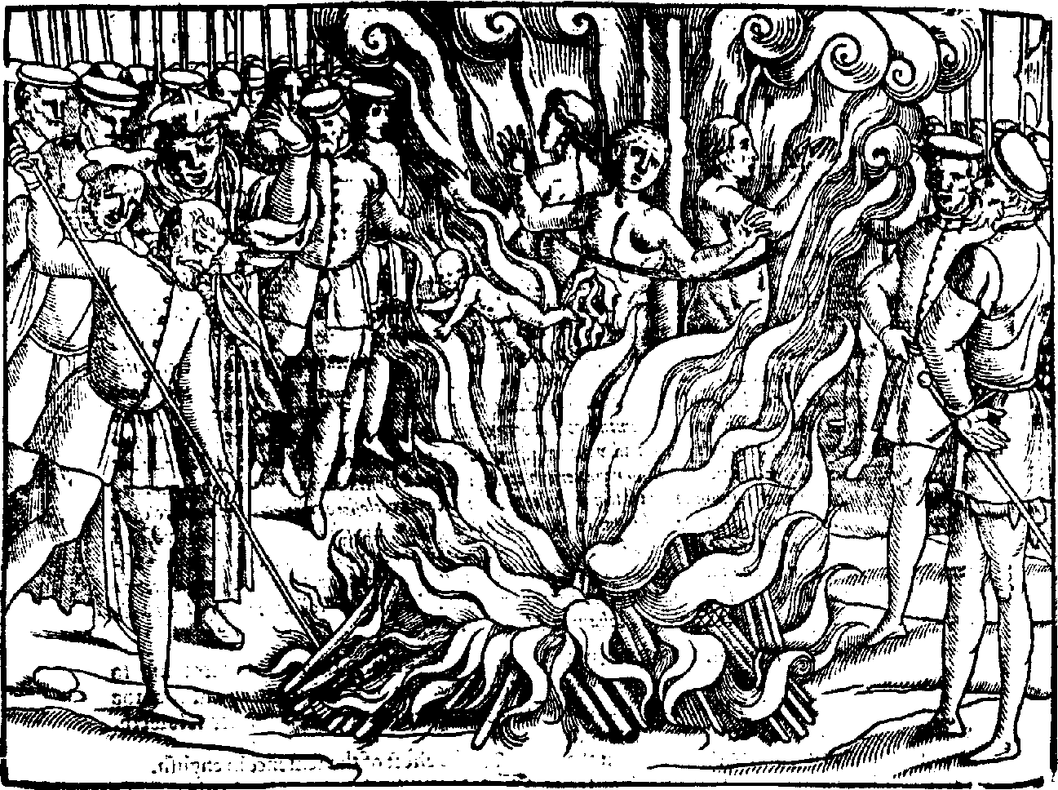
Plate S

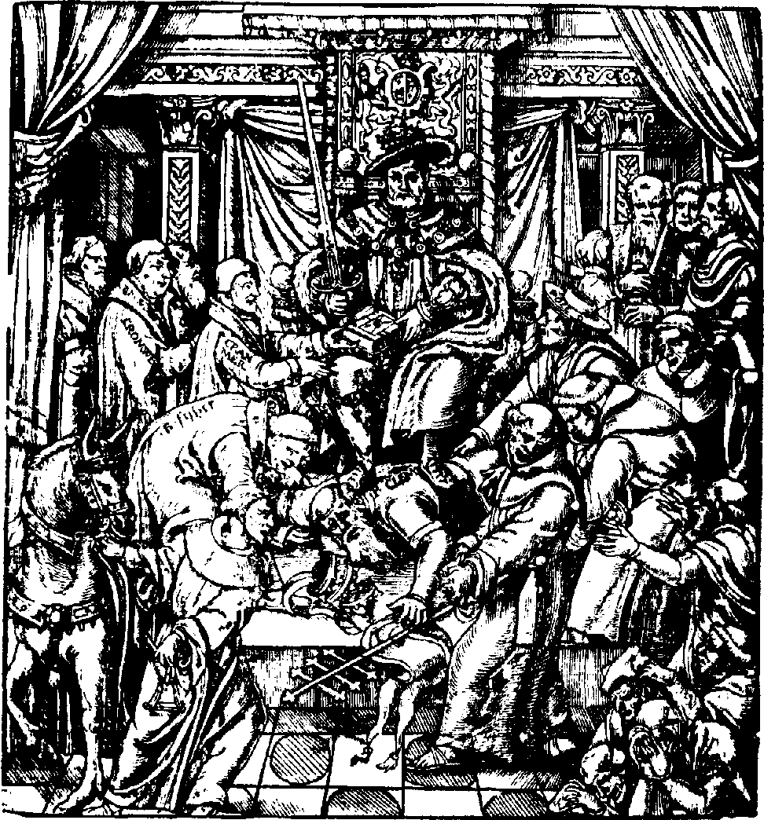
Plate 10

ICONOGRAPHY OF FOXE’S BOOK OF MARTYRS 19
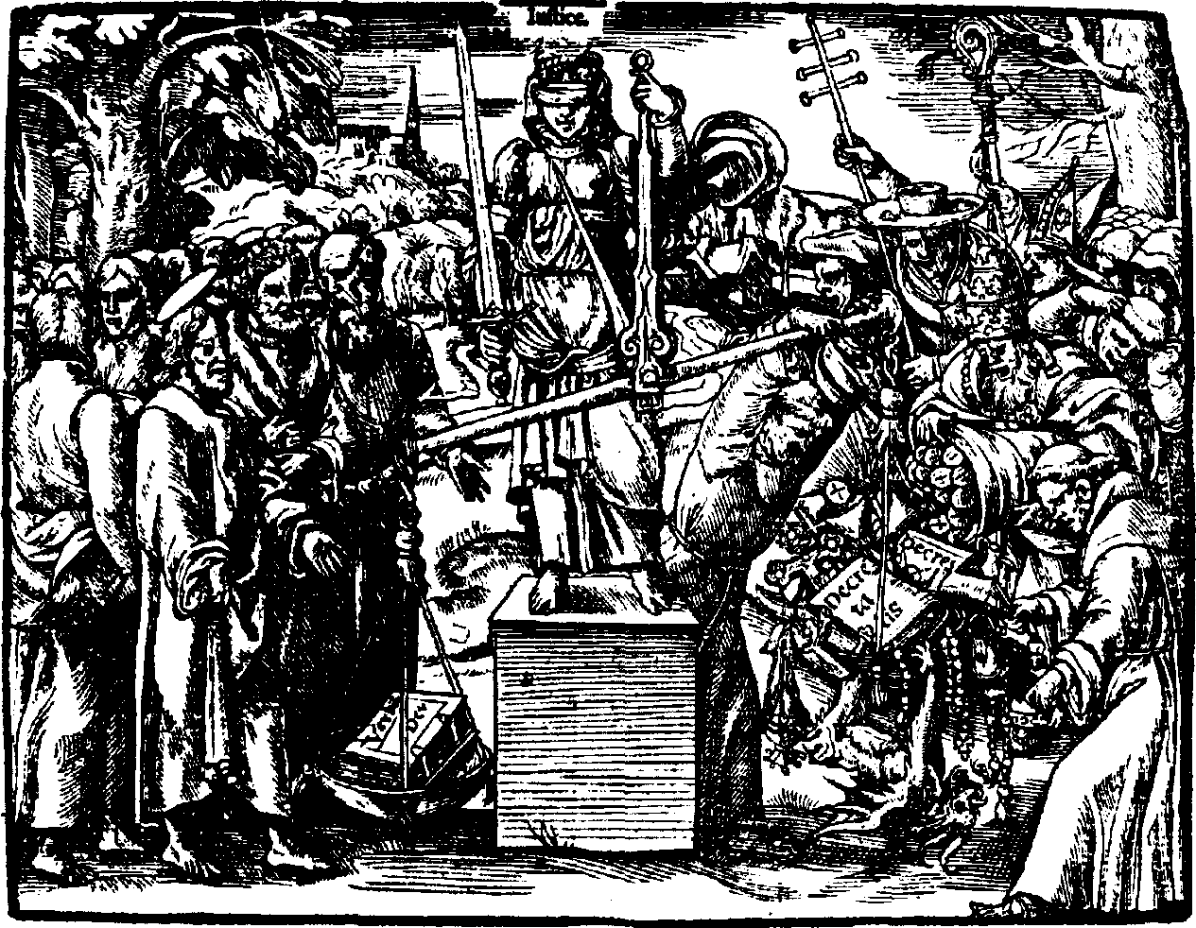

Plate 11

ish friar, and the throng of onlookers. The eye is inevitably drawn toward Cranmer’s dramatic gesture, as he makes good on his promise. Foxe’s de- scription of the scene is simple and straightforward, but in its own manner rises to the height of the occasion:
And when the wodde was kindled, & the fyre began to bum nere him, stretching out his arme, he put his right hand in the flame, which he held so stedfast and immovable (saving that once with the same hand he wyped his face) that all men might see his hand burned before his body was touched.°°
Possibly the most sensational of the woodcuts was that which depicted the burning of the so-called Guernsey martyrs (see plate 9). According to Foxe’s account, which was included in the first edition but expanded in the second, Perotine Massey, her two daughters, and an infant to which she gave birth in the flames at the stake, were burned by the Catholic authorities of Guernsey in 1556. Having been rescued initially, the baby apparently was ordered cast back into the flames by the provost and the bailiff. “And so the infant,” Foxe concludes, “Baptized in his owne bloud, to fil1 up the number of Gods innocent Saintes, was both borne and dyed a Martyr, leav- ing behind it to the world, which it never saw, a spectacle wherein the whole world may see the Herodian crueltie of this graceles generation of Catholicke tormentors.”°' Foxe’s words and the visual image collaborate in this highly
’!*Ibid., p. 1502.
°*Eccelesiasticall History , pp. 212&-29.

20 HISTORICAL MACAZINE

controversial scene as nowhere else in the book to r roduce an i 'r act of un-
surr assed emotional intensity.
Among the illustrations which Foxe introduced in subsequent editions of
the book were several which focused on the broader issues of Reformation r olemics. One of the most striking of these shows Henry VIII seated on his throne, sword in hand, with Por e Clement VII r inned beneath his feet (see
r la te 10). Cranmer is r resenting the English Bible to the king while Thomas Cromwell stands near by. Cardinal Pole and Bisho r J hn Fisher frantically intercede for the fallen r ontiff, whose crown lies dashed on the floor by his side.
Another noteworthy addition focussed on the theme of Justice and the Word of Cod (see r late 11). The blindfolded Justice is shown holding her scales, a sword in her right hand. The Bible in the r an to the left handily outweighs the assortment of r ar al tru '• r ery hear ed high in the r an to the right. The sober but confident Protestants look on from the left, while the
confused Catholic dignitaries frantically r' e on more items on the right. A grotesque devil hangs susr ended like a monkey from the Catholic r an, as he attemr ts to tir the scales back in that direction.
Illustrations such as these must have had a tremendous arr eal for English-
men in the second half of the sixteenth century. By r roviding visualizations of key elements of the contents of the book they undoubtedly exr anded, and at the same time, conditioned its influence. The monumentality of the design of the title r age, the glimpses of r ersonal tragedy revealed in the
faces of victims and relatives alike, the boldness of the rer resentation of the
Cuernsey scene, and the dramatic quality of the der iction of Cranmer’s ges- ture at the stake, all combine to r lace Foxe and his illustrator in the same league with their continental Protestant r redecessors and contem r oraries in the elective ar pror riation of r or ular visual images for religious r olemical purposes.

Perha r s the most r ersuasive testimony to the eEect of Foxe’s book is the
haste with which the Catholics began to answer it. As early as 1565 Thomas
Harding turned aside from his controversy with John Jewel to attack “that huge dongehill of your stinking martyrs, which ye have intituled Actes and monuments.” 22 According to Harding, Foxe “hath into that Huge volume infarced lyes, moe in number, and notabler for vanitie, then ever were raked
together into any one hear e, or booke.”23
Nicholas Harpsfield, who Foxe had described as “the sorest, and of leste com r assion ”2^ of the r ersecuting archdeacons under Mary, continued the assault the following year, in his Dialogi See. Thomas Star leton, one of the
most resr ected controversialists of the time, joined the fray in 1567, direct-
ing his Counterblast in part against Poxe’s “madde martyrloge” and the “develish dirty donghil of his fowle heretical and trayterous Martyrs.”25
2zA Con/utotion o/ a Booze intituled an Apofogie o/ the C'hurch o/ England
(Antwerpe: Ihon Laet, 1565), fo1. 14*.
**A Reiooidre to M. levels Replie against the Sacri e o{ the Mosse (Lovanii: loannem Foulerum, 1567), fo1. 184*.
24@p{es and Monuments, p. 1546.
2S@ uoterbfast to M. homes Vayne Blaste Against M. Fekenhoni (Lovanii: Joannem Foulerum, 1567), sig. P4*.

ICONOGRAPHY OF FOXE’S BOOK OF MARTYRS zi
By the end of Elizabeth’s reign the Jesuit Robert Parsons was prepared to label Foxe “the most fraudulent and perfidious wryter that ever put pen to paper in our language.” 26 He may have been closer to the mark when he charged that the Book of Martyrs “hath done more hurt alone to simple soules in our countrey by infectinge and poysoninge them unwares, under the bayte of pleasant historyes, fayre pictures, and painted pageants, then many other the most pestilent bookes togeather.”*°
But even before Foxe’s death in 1587 the extent of the impact of his work was already becoming apparent. Catholic reactions notwithstanding, the Book of Martyrs remained the most widely read, as well as the most inBu- ential account of the Marian persecution. For good or ill it almost single- handedly established the reputation of the Queen as “Bloody Mary” and the memory of her religious victims as martyrs. In the process, it virtually damned the cause of Roman Catholicism in England for centuries to come. The iconography of the book, by an unknown artist, played no small part in indelibly impressing Foxe’s images upon the popular imagination.

2GTfi e Wera-Word to Sir Francis Hastings Wast-Word (1602), fol. 120°.
*’A Treatise o| Three Clonveisions o| Eaglaad, {rom Paganism to Christian Reli- gion, 3 vols. (1603-1604), 3:400.

License and Permissible Use Notice

These materials are provided to you by the American Theological Library Association (ATLA) in accordance with the terms of ATLA’s agreements with the copyright holder or authorized distributor of the materials, as applicable. In some cases, ATLA may be the copyright holder of these materials.

You may download, print, and share these materials for your individual use as may be permitted by the applicable agreements among the copyright holder, distributors, licensors, licensees, and users of these materials (including, for example, any agreements entered into by the institution or other organization from which you obtained these materials) and in accordance with the fair use principles of United States and international copyright and other applicable laws. You may not, for example, copy or email these materials to multiple web sites or publicly post, distribute for commercial purposes, modify, or create derivative works of these materials without the copyright holder’s express prior written permission.

Please contact the copyright holder if you would like to request permission to use these materials, or any part of these materials, in any manner or for any use not permitted by the agreements described above or the fair use provisions of United States and international copyright and other applicable laws. For information regarding the identity of the copyright holder, refer to the copyright information in these materials, if available, or contact ATLA at products@atla.com.

Except as otherwise specified, Copyright 0 2016 American Theological Library Association.

